**Assignment-13**

# Create a WorkMail for Your Organization

**Objective:**

Set up a business email using **Amazon WorkMail** for your organization.

## Q What is Amazon Work Mail?

Amazon WorkMail is a **secure, managed business email and calendar service** that works with existing desktop and mobile email clients like **Microsoft Outlook**, **iOS Mail**, and **Android Mail**. It lets users access email, contacts, and calendars from anywhere.

# 🛠️ Steps as follows:-

## Step 1: Log in to AWS Console

* Open [AWS Management Console](https://aws.amazon.com/console/).
* Sign in using your credentials.

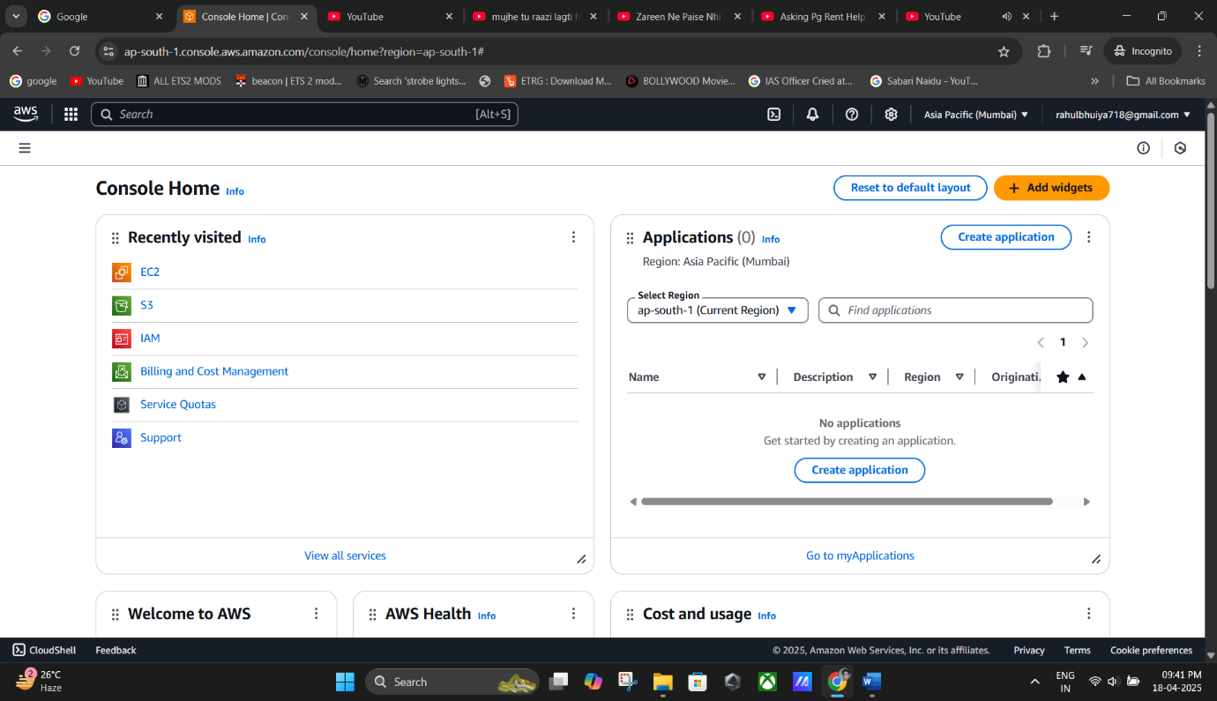

## Step 2: Open Amazon WorkMail Service

* In the AWS Console search bar (at the top), type **“Amazon WorkMail”**.
* Click on **Amazon WorkMail** from the search results.

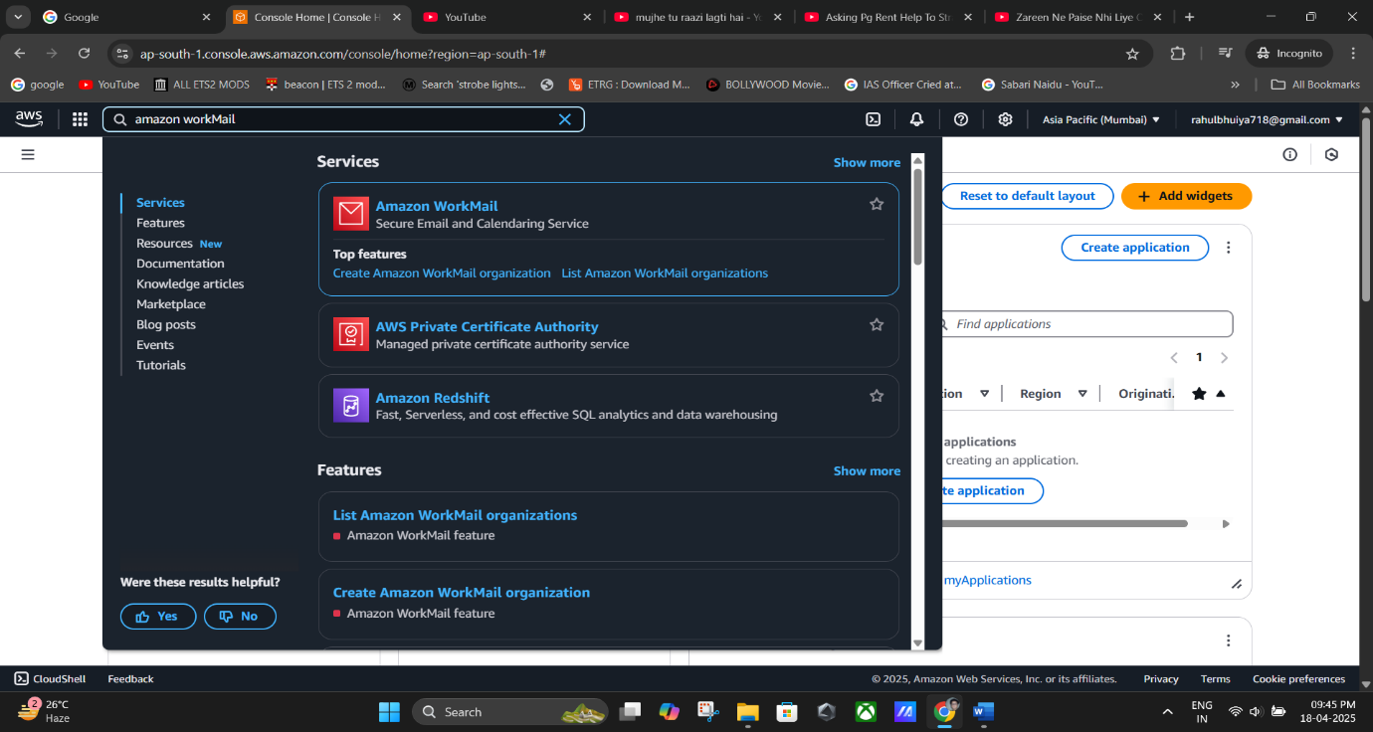

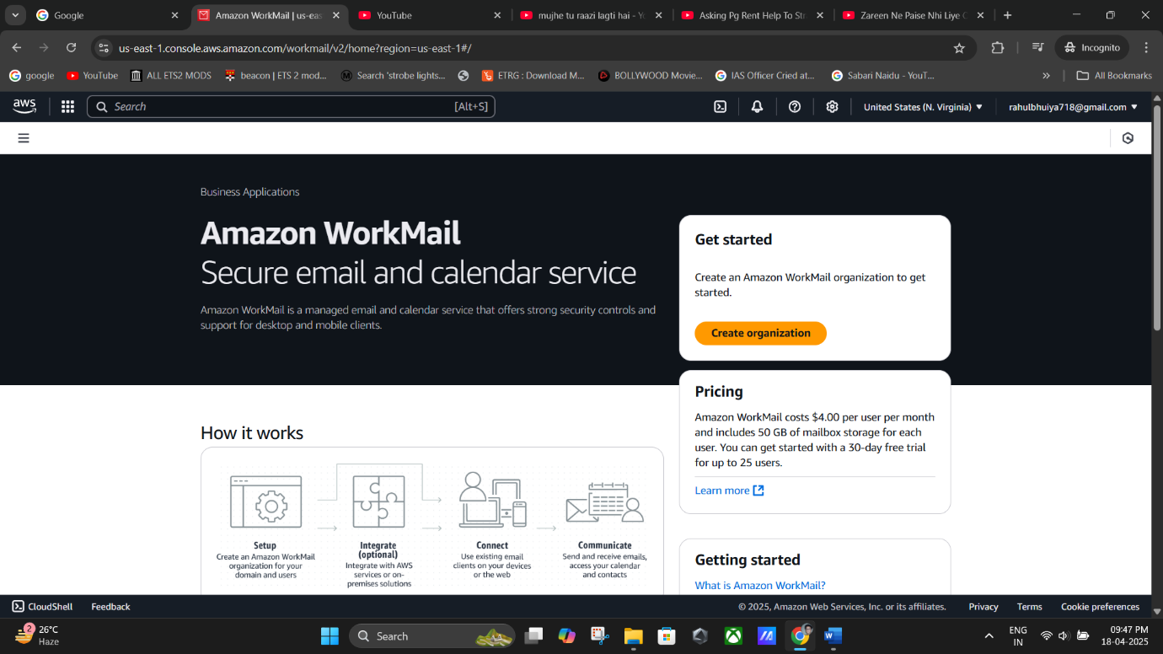

## Step 3: Create a New Organization

* Click on **“Create organization”**.

You will now see the **Create an Amazon WorkMail Organization** page.

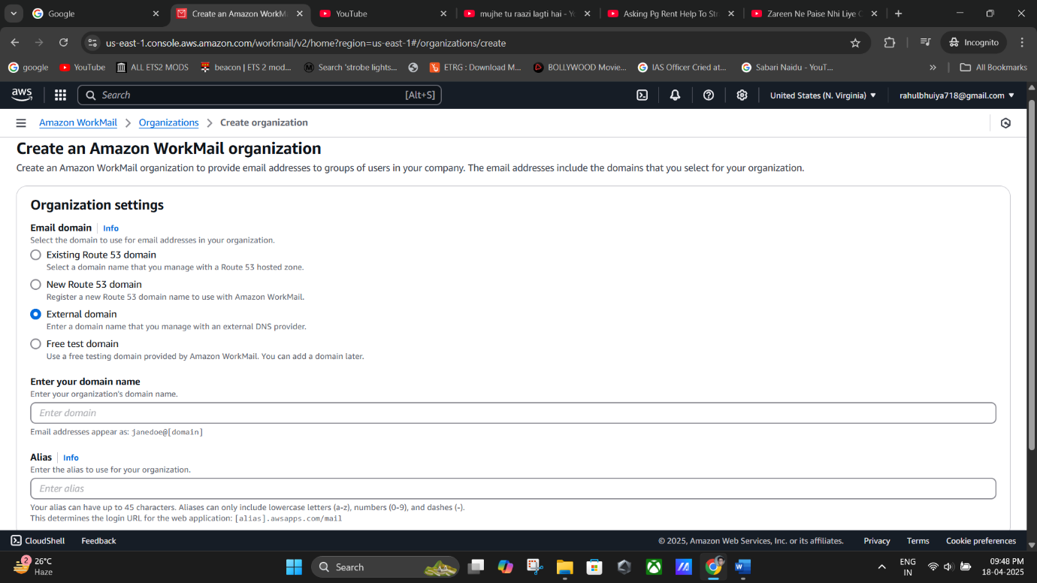

## Step 4: Configure Organization Settings

* Under **Email Domain**, select **“Free Test Domain”** (this allows you to use a test domain provided by AWS).
* Under **Alias**, enter a short and relevant name for your organization.
* For example: l-and-p

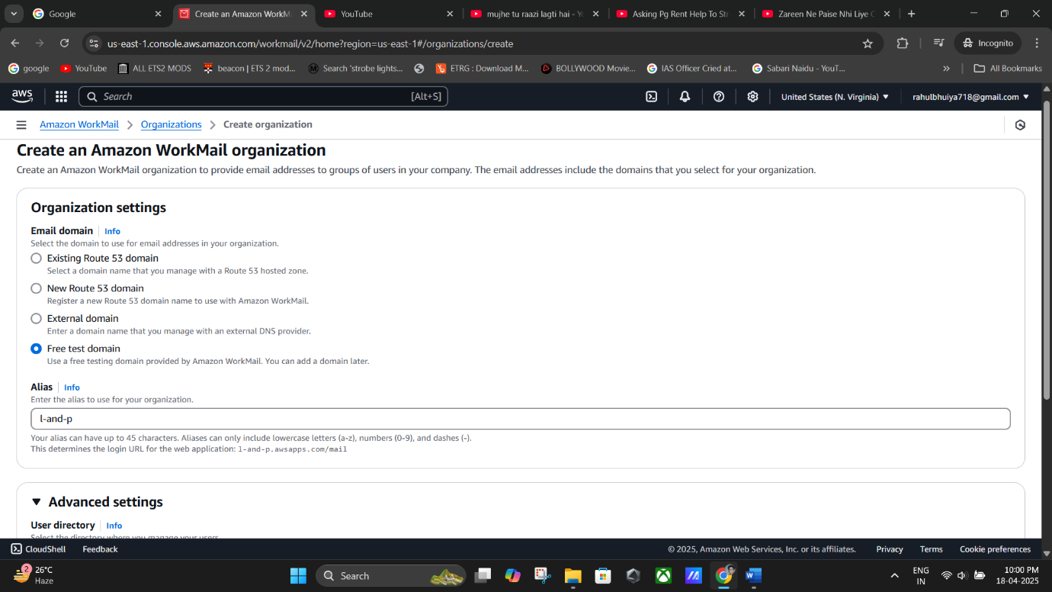Q *Alias is used as part of the email domain, like* l-and-p*.awsapps.com.*

**(Email Domain -> Select “Free Test Domain” -> Under “Alias” name- “*@l-and-p.awsapps.com*”)**

## Step 5: Create the Organization

* Click the **“Create Organization”** button.
* Wait a few minutes while AWS sets up your organization.
* Once it’s done, you’ll see the new organization listed.

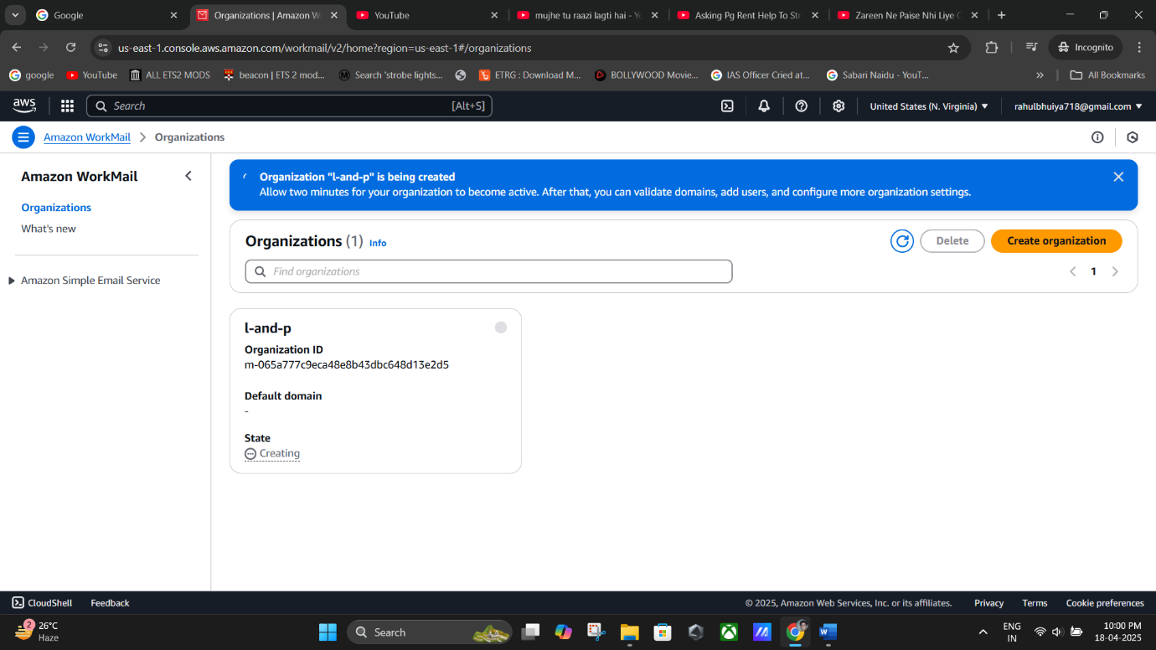

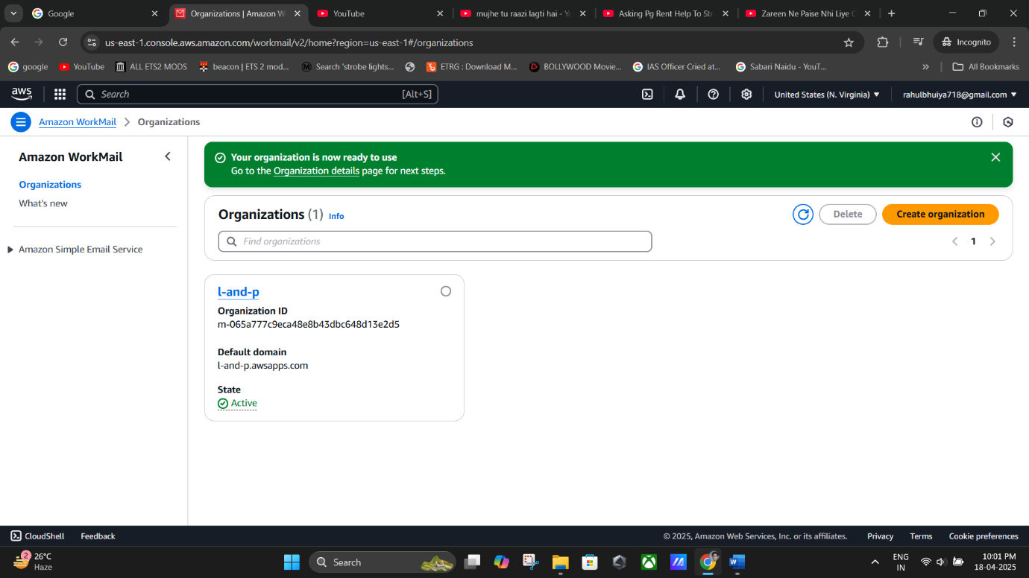**(Create Organization -> “Taking Few Minutes”).**

(**New Organization Created**).

## Step 6: Access the Organization

* Click on the **alias name** of the organization you just created (e.g., l-and-p).

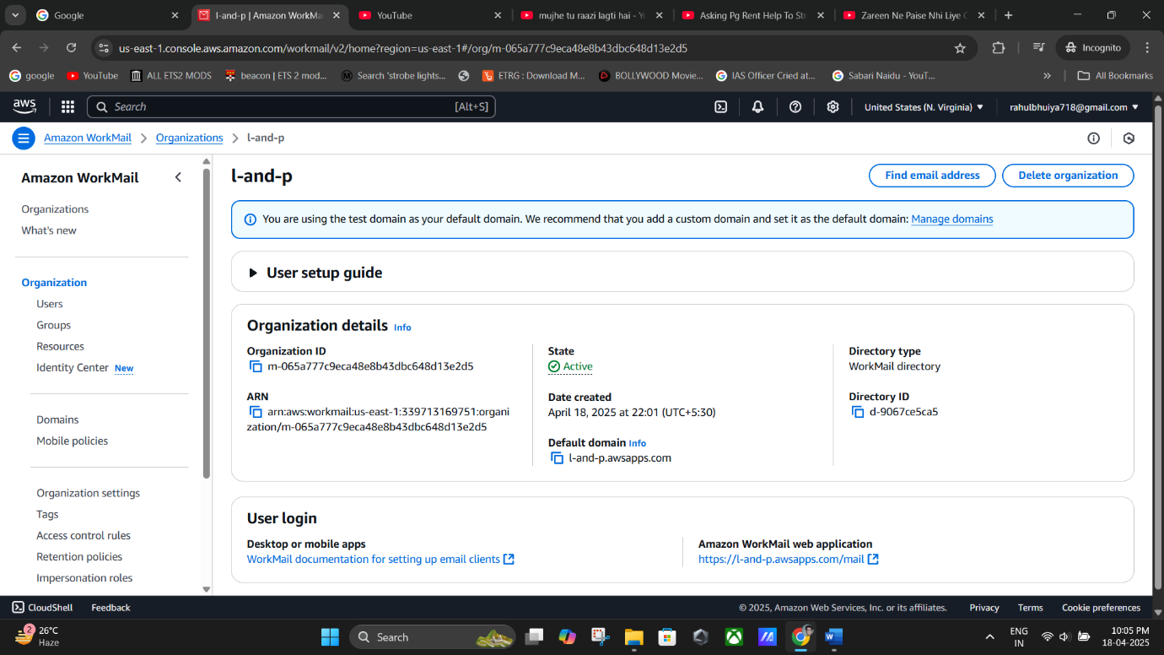

**(Click On the alias name “l-and-p”).**

## Step 7: Create a New User

* On the left menu, click on **“Users”**.
* Click on **“Create User”**.

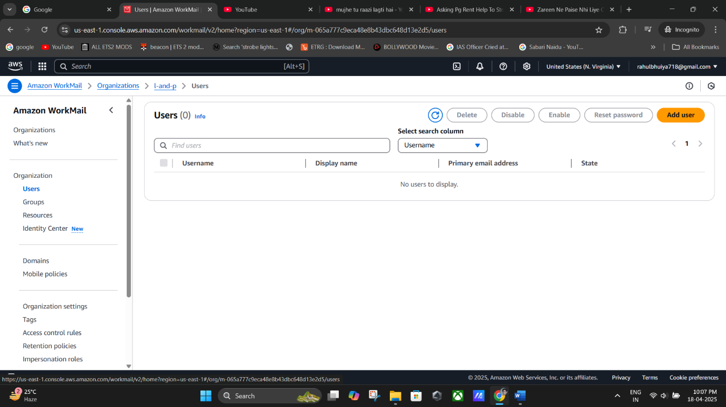

**(Click on “Users” -> “Add User”).**

## Step 8: Fill in User Details

* In the **Create a User** page:
  + **Username**: e.g. R-a-h-u-l
  + **Display name**: e.g. Rahul
  + Optionally, enter **First Name** and **Last Name**.

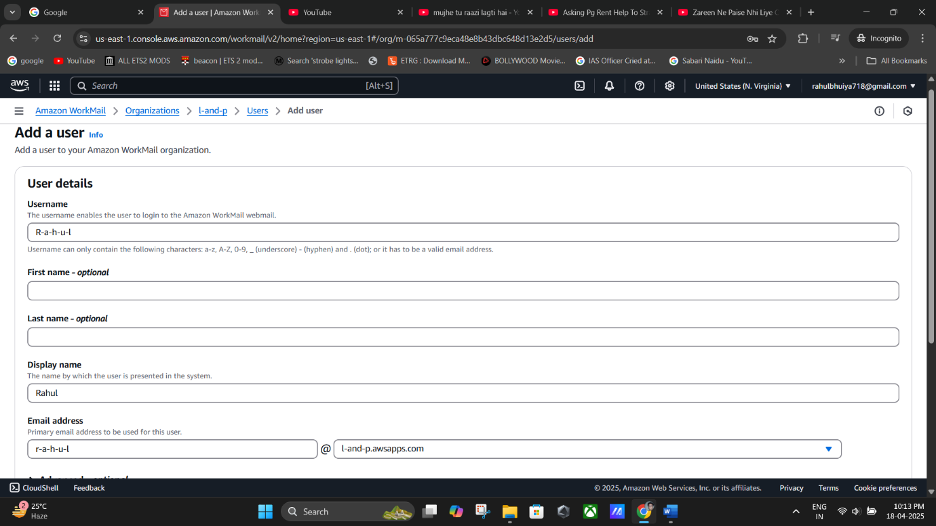

**(Filling The User Details Username: “**R-a-h-u-l**”).**

## Step 9: Set Up Email

* AWS automatically generates the email in this format:
* <username>@<organization-name>.awsapps.com

Example:  [R-a-h-u-l@l-and-p.awsapps.com](mailto:%20R-a-h-u-l@l-and-p.awsapps.com)

* Set a **password** and confirm it.
  + **Password: Rahul@123**
* Click on **Add User**.

✅ *The user is now created and will appear in the list.*

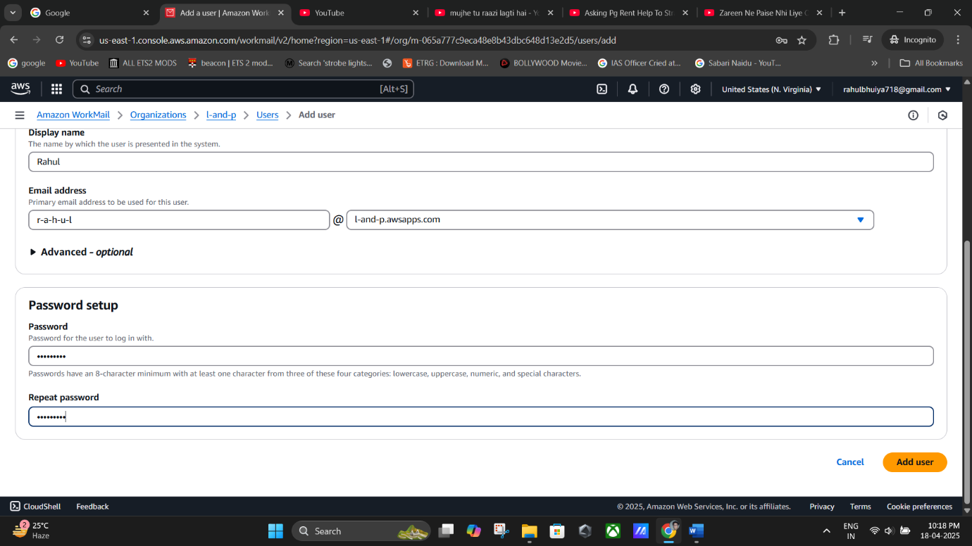

**(Setting Up the Password).**

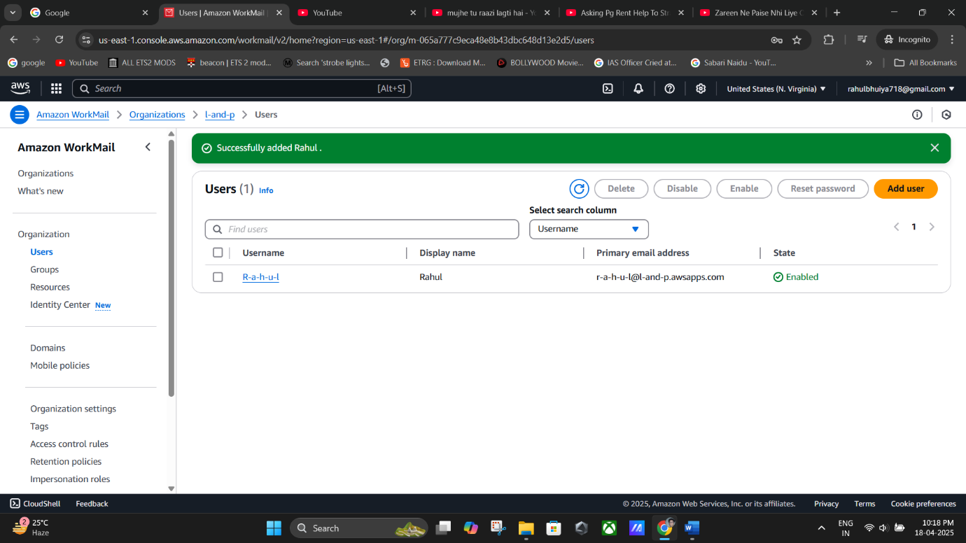

**(Click on “Add User” -> The User will be Created & Appear on the list).**

## Step 10: Log In to Amazon WorkMail Web Application

* Go back to the **organization details page**.
* Look for the **Amazon WorkMail web application** link and click it.
  + This will open the WorkMail login page.

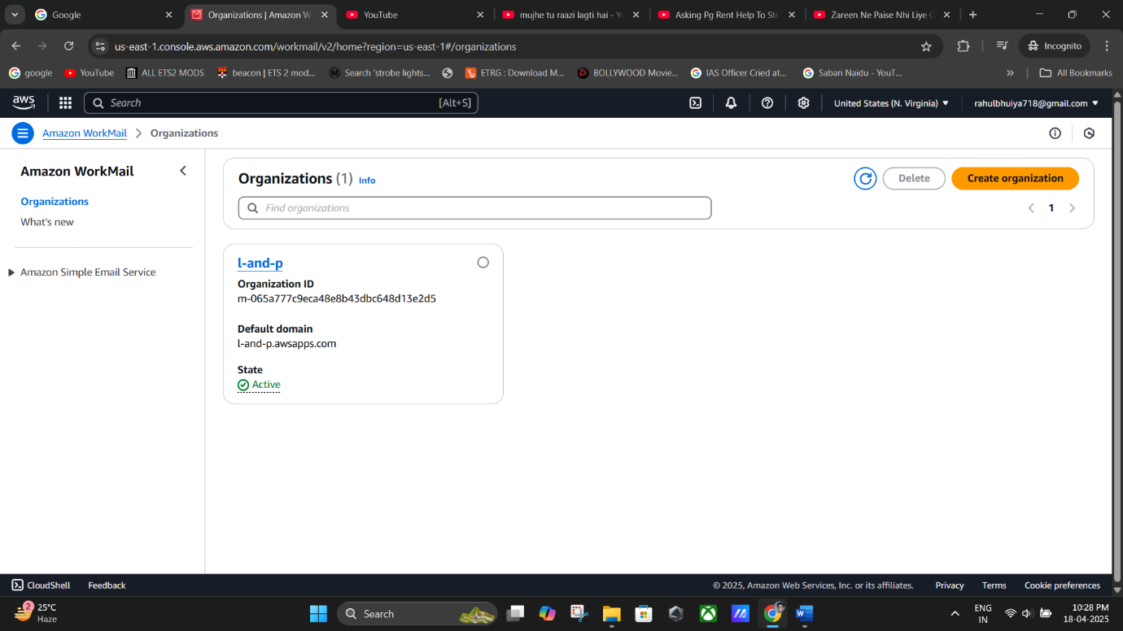

**(organization details page).**

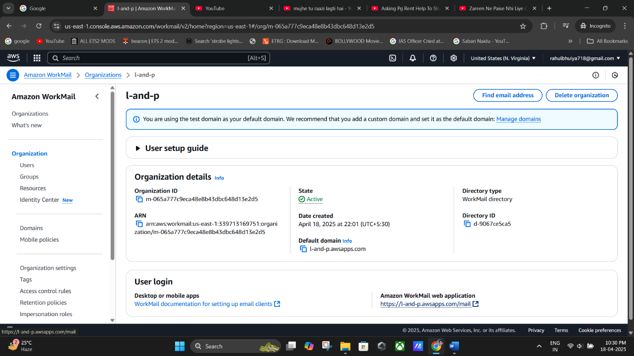

**(Amazon WorkMail web application).**

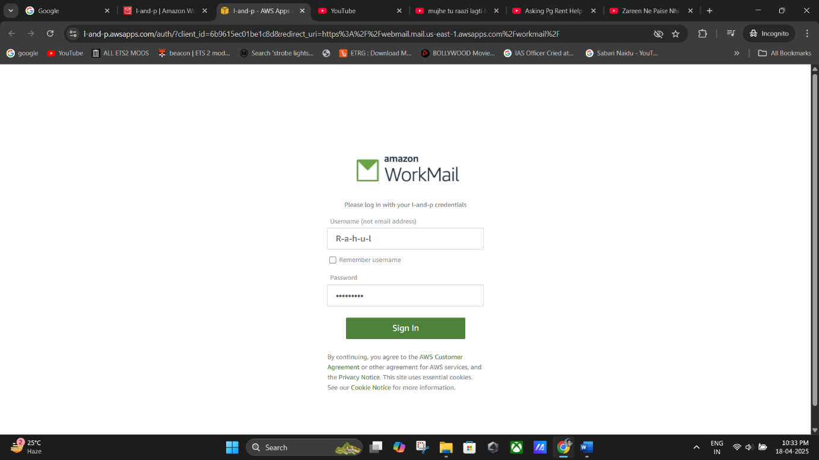

**(WorkMail login page -> Fill The “User Name” & “Password”.)**

## Step 11: Sign In to Webmail

* Use the **Username** (e.g. R-a-h-u-l) and the **Password (Password**: Rahul@123**)** you set earlier.
* Click **Sign In**.

🎉 You’ll be logged into your Amazon WorkMail inbox.

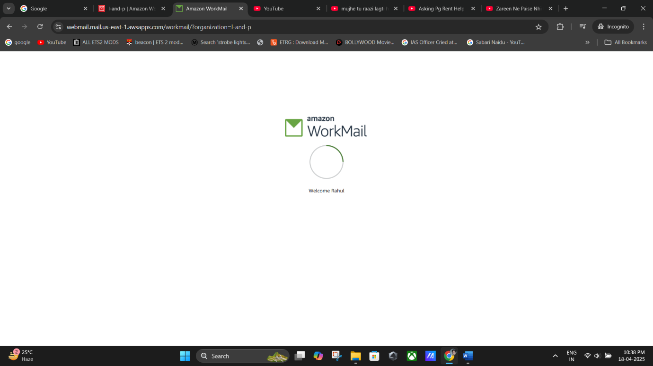

**(Signing In).**

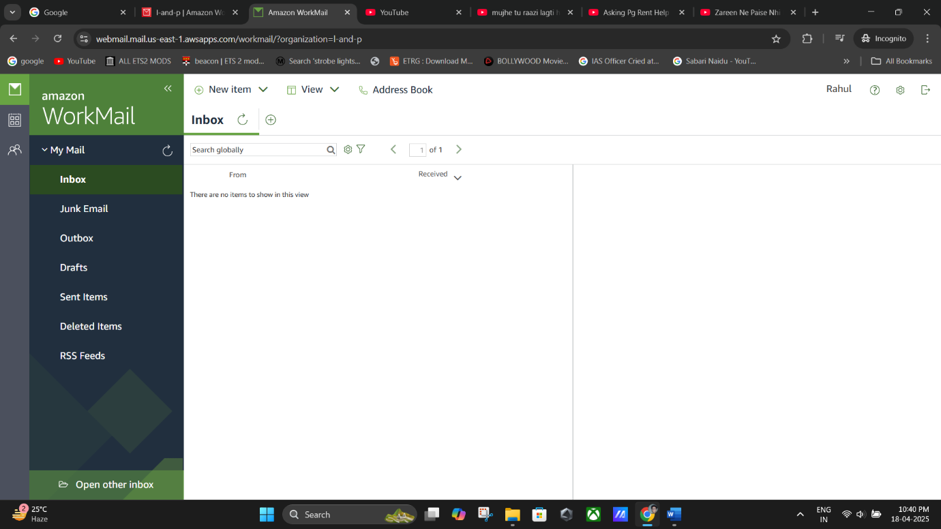

**(Now We are in “Amazon WorkMail inbox”).**

## Step 12: Send and Receive Emails

* To send an email:
  + Click **New item > New Email**
  + In the **To:** field, enter a recipient’s email address.
  + Write a **subject and message**, then click **Send**.
* You can also check your **Inbox** to view any incoming messages.

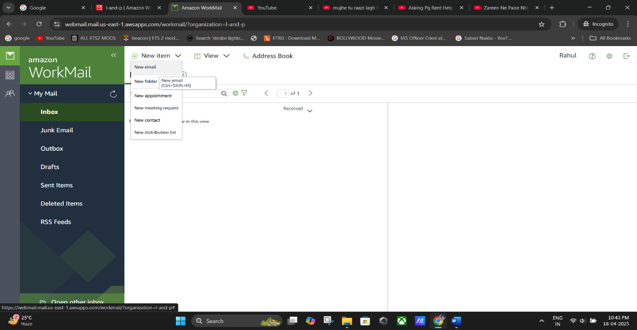

**(Click New item > New Email).**

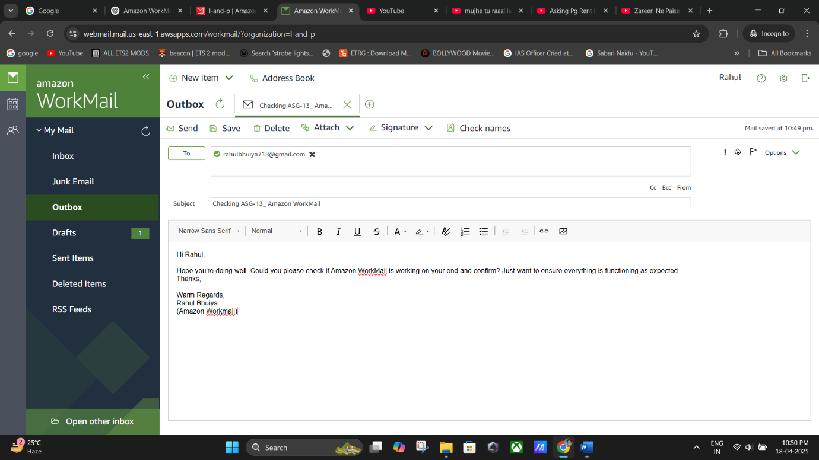

**(Writing This email to** [**rahubhuiya718@gmail.com**](mailto:rahubhuiya718@gmail.com) **-> Click on “Send”).**

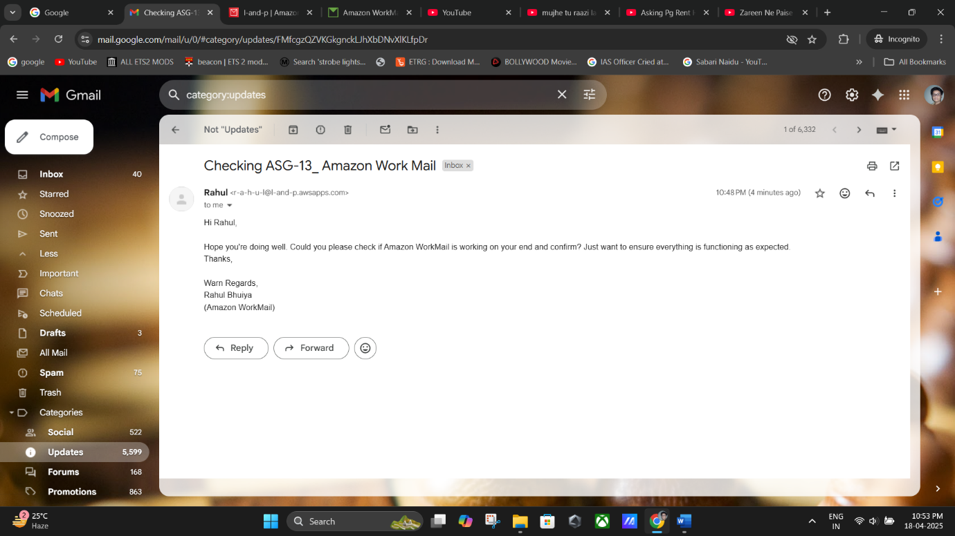

**(“Email Received Confirmed” from the “user end” in the Gmail Account).**

## ❌ Step 13: Delete the WorkMail Setup (Optional Cleanup)

If you want to delete everything:

1. Go to **Users**, and delete all users first.
2. Go back to the organization and choose **Delete organization**.

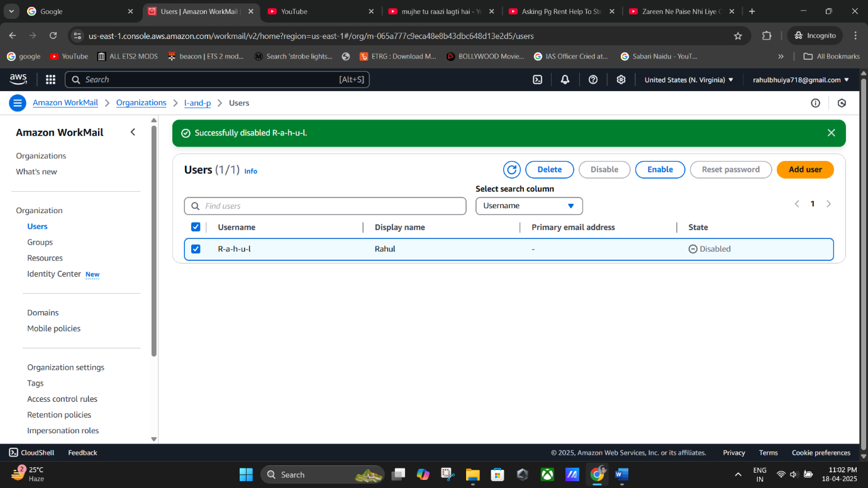

**(Users -> Select “R-a-h-u-l” -> Disable -> Delete).**

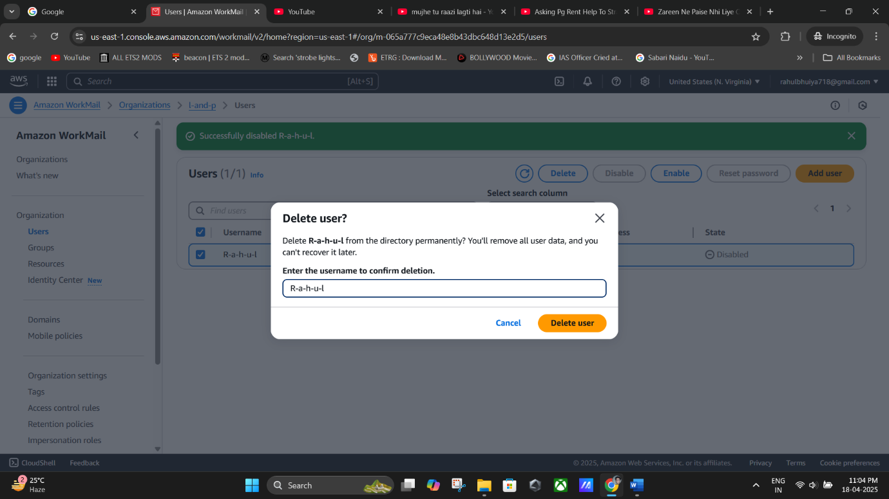

**(Delete Uesr).**

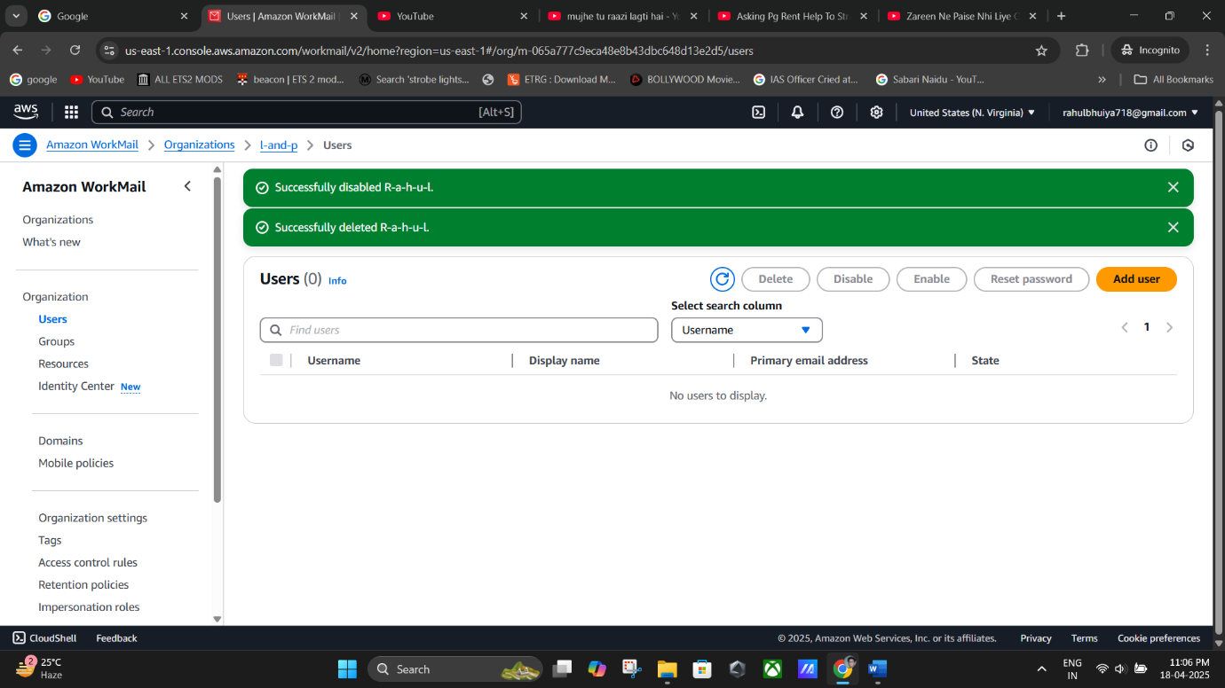

**(User Deleted Successfully).**

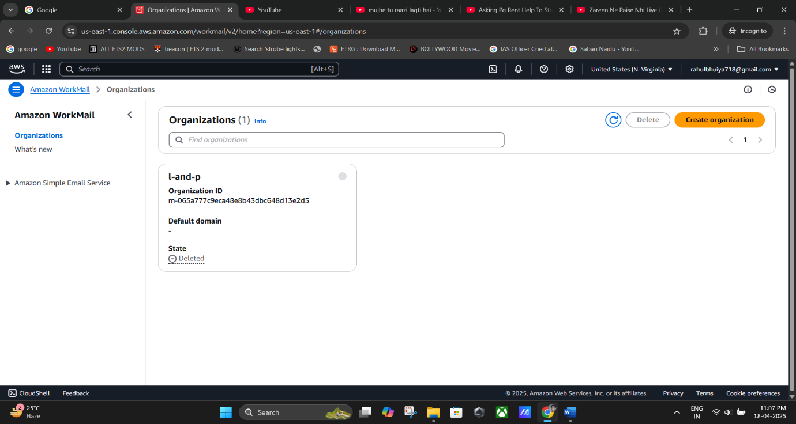

**(Organization Deleted Successfully).**